STAMP VALUE CALCULATOR FOR POSTAGE NEEDS

ABSTRACT

The aim of this project is to develop a stamp value calculator for the postal operations that is carried out in a post office. These postal letters are tariffed at the post offices depending on the weight of the postal letter measured on a weighing scale. Normal weight checking instruments used in the shops like the grocery stores are not applicable in post offices, where the weights range from kilograms and above, but in post offices the weights are considered in the order of grams and the tariff rate is imposed accordingly. Hence, there is a need of a precise weighing scale that can measure the weights in grams and display it. This concept can be achieved by an electronically weighing machine. This proposed system can fulfill the desired functionality and it is exact in its precise weight measurement and price of the stamp required.
This system is built upon using a PIC microcontroller, which uses weight sensor by a spring loaded variable resistor to determine the weight of the particular letter placed on it. This data is processed through an ADC which is interfaced to the microcontroller to generate an appropriate display on the LCD, both in terms of weight and its corresponding stamp value required.
This project can be enhanced by integrating a mini printer with this system, which can be used for printing the value of stamp for franking machines. It can also be interfaced with a keypad and an EEPROM to store the price details corresponding to its weight.

BLOCK DIAGRAM
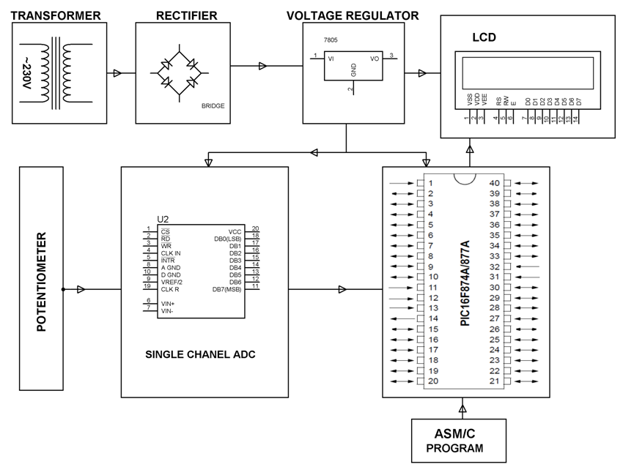
HARDWARE REQUIREMENTS:
Transformer, Bridge Rectifier, Regulator, PIC series Microcontroller, LCD, ADC, Potentiometer.
SOFTWARE REQUIREMENTS:
HI-TECH PICC Tool suite
Language: Embedded C or Assembly.

